Congo, Dem. Rep.

## Political Stability Estimate Data

The data set shows the political stability estimate of the country each year.

## # A tibble: 19 x 5  
## country iso3c date stability stabilityCategory4  
## <chr> <chr> <dbl> <dbl> <chr>   
## 1 Congo, Dem. Rep. ZAR 1996 -2.68 highly unstable   
## 2 Congo, Dem. Rep. ZAR 1998 -2.84 highly unstable   
## 3 Congo, Dem. Rep. ZAR 2000 -2.48 highly unstable   
## 4 Congo, Dem. Rep. ZAR 2002 -1.98 highly unstable   
## 5 Congo, Dem. Rep. ZAR 2003 -2.03 highly unstable   
## 6 Congo, Dem. Rep. ZAR 2004 -2.39 highly unstable   
## 7 Congo, Dem. Rep. ZAR 2005 -2.13 highly unstable   
## 8 Congo, Dem. Rep. ZAR 2006 -2.25 highly unstable   
## 9 Congo, Dem. Rep. ZAR 2007 -2.18 highly unstable   
## 10 Congo, Dem. Rep. ZAR 2008 -2.01 highly unstable   
## 11 Congo, Dem. Rep. ZAR 2009 -2.00 highly unstable   
## 12 Congo, Dem. Rep. ZAR 2010 -2.20 highly unstable   
## 13 Congo, Dem. Rep. ZAR 2011 -2.21 highly unstable   
## 14 Congo, Dem. Rep. ZAR 2012 -2.09 highly unstable   
## 15 Congo, Dem. Rep. ZAR 2013 -2.19 highly unstable   
## 16 Congo, Dem. Rep. ZAR 2014 -2.17 highly unstable   
## 17 Congo, Dem. Rep. ZAR 2015 -2.15 highly unstable   
## 18 Congo, Dem. Rep. ZAR 2016 -2.23 highly unstable   
## 19 Congo, Dem. Rep. ZAR 2017 -2.30 highly unstable

## Political Stability Estimate Plot

The plot shows the trends of stabilization and destabilization for the each country.

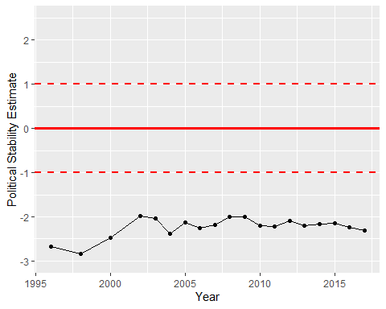

Political Stability Trend